**EE316 assignment4 Homework**

12112441 曹子惠

4.1 Design an amplifier for maximum gain at 8 GHz using single-stub matching sections. Read the material attached. You are required to use smith chart and ADS to solve the problem (not the equations)! Use ADS and plot the input return loss and gain from 4 to 12 GHz. The transistor is a GaAs MESFET with the following scattering parameters (Z0=50Ω):

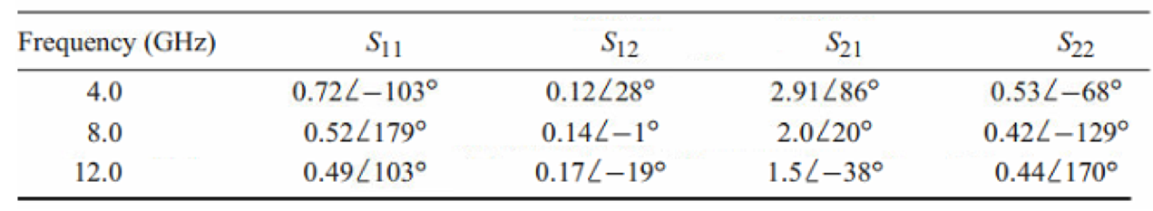

Also please check the stability condition at all 4, 8 and 12GHz.

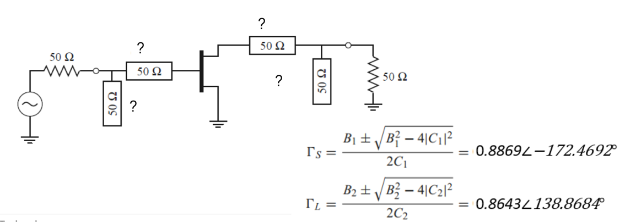

The Answer:

First use the Smith chart to calculat the ?’s parameters, and import S-parameters, I get circuit below:

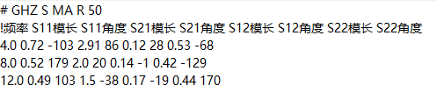

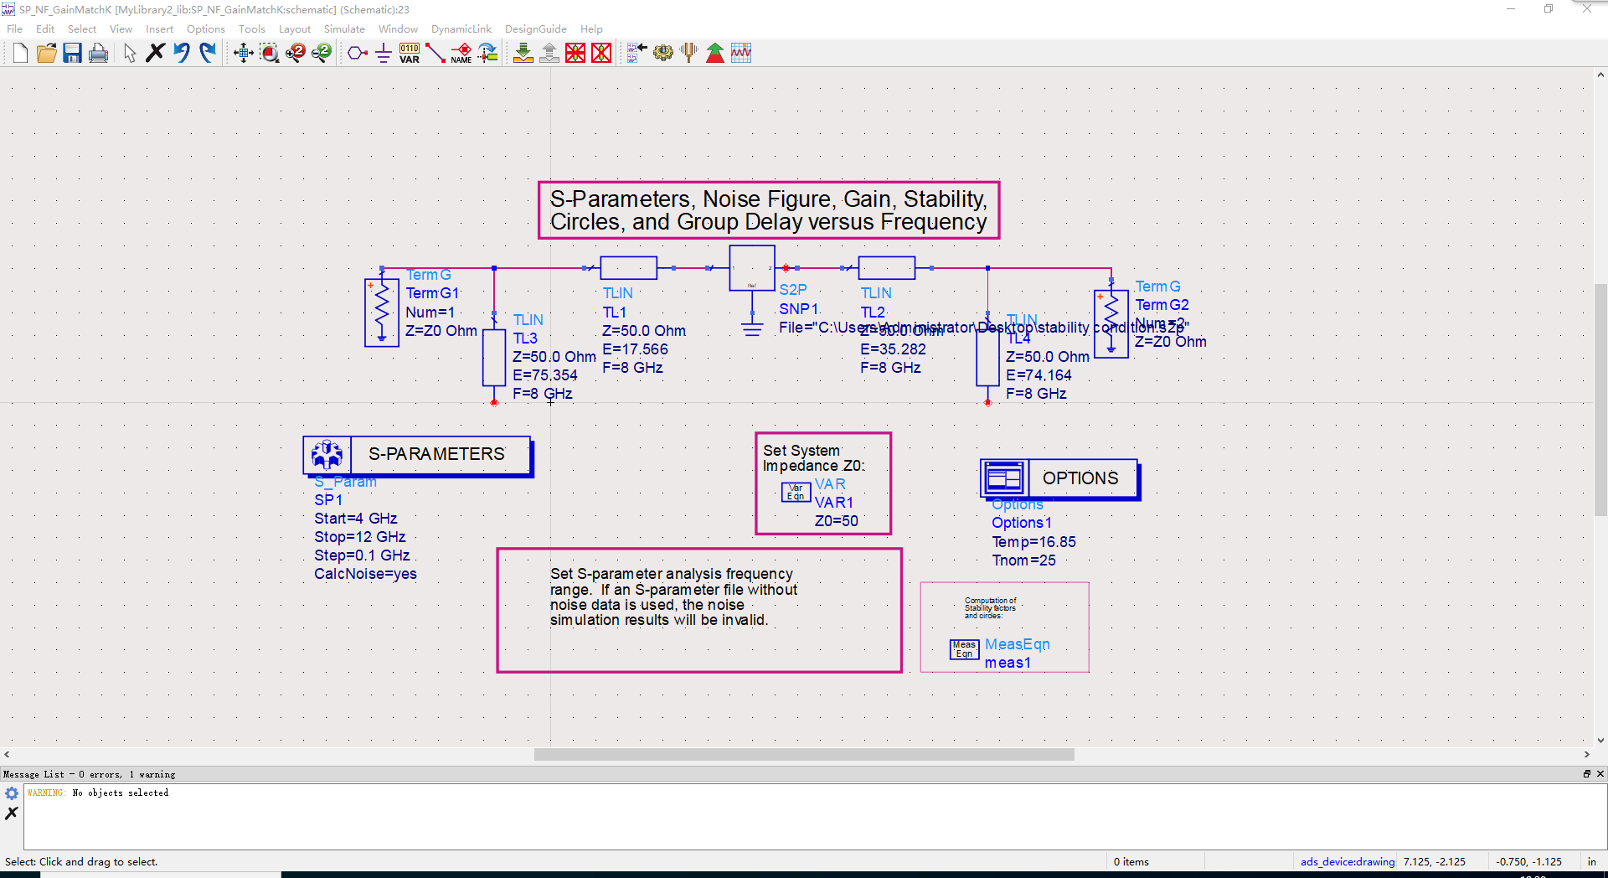

And simulate, get the input return loss and gain from 4 to 12 GHz:

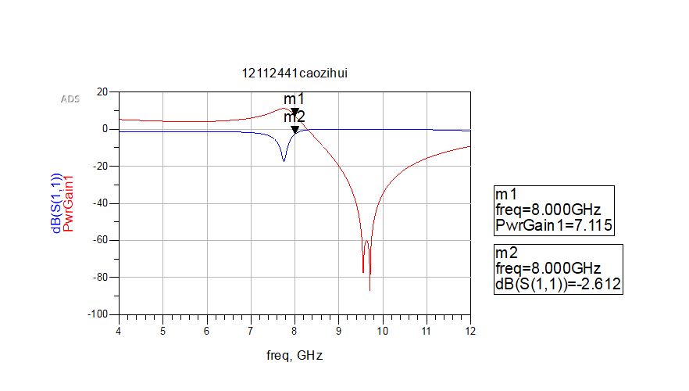

To check the stability condition at all 4, 8 and 12GHz, we need check mu, K, and G:

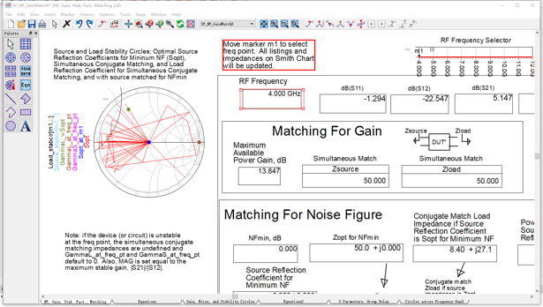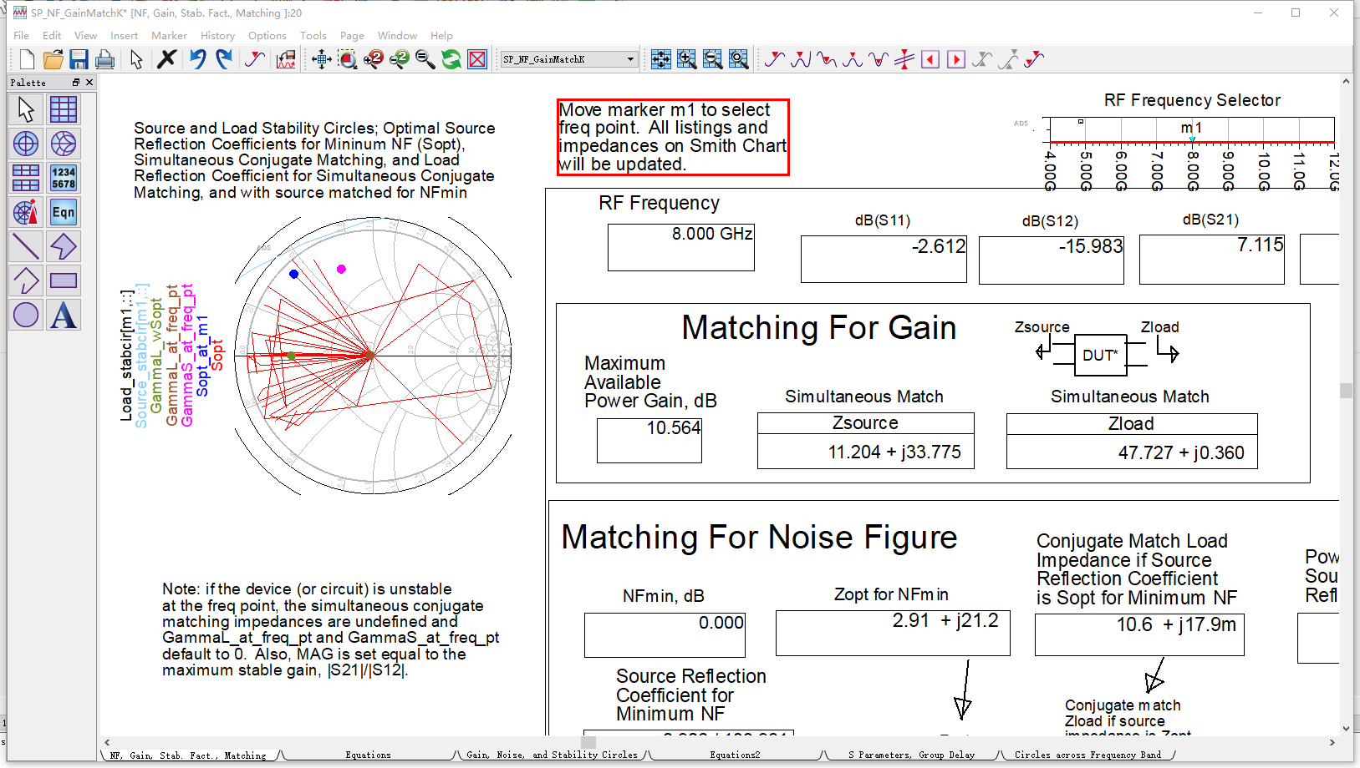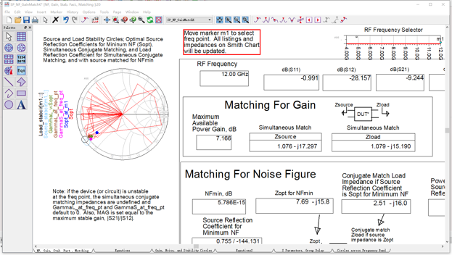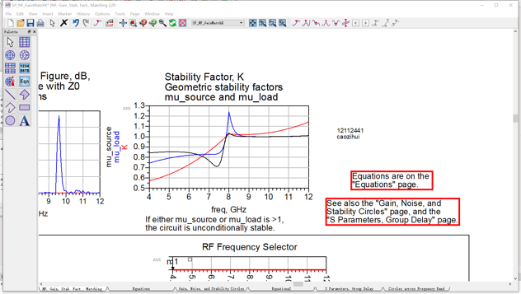

So it’s clear that at 4GHz, unstable; and at both 8GHz and 12GHz, unconditionally stable.

4.2

